January 3rd, 2010
Hi
Last Monday was the coldest day of the winter so far with the overnight temperature down to about 9⁰C. However, this is hardly cold compared to your temperatures. On Monday, I went to the local government clinic and got my human H1N1 jab.

On Tuesday, a British man with mental illness executed in China for bringing in a suitcase of heroin. He seems to have been tricked by a gang in Poland to bring in the drugs. The Chinese government never considered possible mental illness and during his trial, judges even laughed at some of the replies the man made. This, together with the 11-year jail sentence on the dissident Liu Xiao-bo plus other crackdowns has suggested to commentators that humans rights in China are going backwards as the government asserts its growing power. Not a good sign. On Friday there was a march in HK, which eventually turned violent, to protest Li Xiao-bo’s sentence and lack of universal suffrage here.
On Thursday, I had the stitches on my nose removed and got the results of the biopsy – sBCC (superficial Basal Cell Carcinoma). So I will have to have plastic surgery sometime to have it removed.

Did you know that in January there is a ‘blue moon’, i.e. a month in which the moon appears twice? It occurs in HK and also in the US.
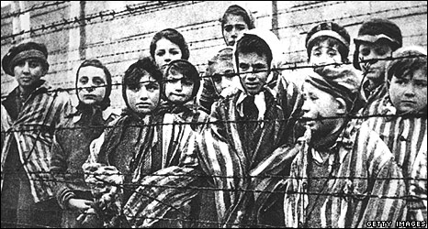
There was a very interesting BBC interview on New Year’s Eve (which was more interesting than watching the fireworks display over Sydney Harbour) with a former British special forces soldier who was captured at El Alamein, escaped and was captured again in Greece. He ended up as a prisoner in a POW in a camp adjacent to the Auschwitz concentration camps in Poland. There the POWs had to work alongside inmates from the concentration camps. This guy befriended an Auschwitz inmate and on several occasions swapped clothes so that he could get into the camps to find out what was happening!! Incredible – when everyone wanted to get out, he wanted to get in! The inmate would be smuggled back to the POW camp by others in on the plan who would wash, feed and treat him. The POW sent coded letters back to his family about what was happening. Also, the POW passed on gifts sent to him (via the Red Cross) to the inmate which were used as bribes including to get his shoes resoled. This saved his life during the forced march out of the camps during the winter of 1944-45 as the Russians were advancing. Have a look at the websites below. Very interesting.
http://news.bbc.co.uk/2/hi/8382457.stm
http://news.bbc.co.uk/2/hi/uk_news/8433968.stm
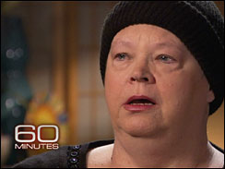
On 60 Minutes the other evening, there was an item on the poor state of health care in Las Vegas because of the economic downturn. The UMC (University Medical Centre – though I do not know which university) was treating many people, but very reluctantly had to stop when funding dried up essentially handing a death sentence to some patients with cancer or who needed dialysis. (Perhaps Sarah Palin should take a visit there to see her so-called ‘death panels’ at work!) Ironically, this did not affect the poorest of the poor in Nevada who were still entitled to treatment but the lower middle class who could not afford insurance or who had insurance which was not accepted by health care providers. The inspiring part of this dreadful story was the doctors from the centre who put in their own money to treat some of the patients and would go around shops with boxes begging for donations. For more on this, go to the following website:
http://www.cbsnews.com/stories/2009/04/03/60minutes/main4917055.shtml
Went for the weekly run yesterday in the Cloudy Hill area behind Hon Lok Yuen, where as I remind you each year, many years ago Gavin accidentally started a motor at a construction site and got the fright of his life. Cloudy and humid. Took 2 h 44 min. Turned out to be somewhat dramatic as when I stopped to have a pee, I saw that there was blood in my urine! I suspect this was exercise-induced haematuria (i.e. blood in the urine) which can occur during vigorous exercise. The condition, which has been recorded for hundreds of years, is quite common in runners and occurs more is in males than in females. The two possible causes in my case could be:
1. Damage to red blood cells in the soles of the feet due to the pounding they get. Blood leaks out of the damaged cells and finds its way through the kidneys and into the bladder. However, I would think that this cause may be less common nowadays with the much more comfortable running shoes available.
2. Bladder injury due to dehydration. When the bladder is empty, vigorous movement causes the two sides to rub against each other resulting in bleeding. I had had a pee earlier in the run at the 1-hour mark and this would have emptied my bladder but did not drink much water after that. I observed the blood during a second pee at 2.5 hours so during that 1.5 hours the damage could have been done. So dehydration was probably the cause.
When I got back, I had another pee and it looked terrible. I then tanked up with water and the next pee a few hours later was completely normal with no sign of blood, unless it was microscopic haematuria, which is where there may be blood but too little for it to be observed with the naked eye. And today it is also all right.
But the question I ask is why has this not happened before? Yesterday’s run was no more vigorous that other runs, and at 17⁰C, the weather was not so hot that severe dehydration should occur. Further, on this particular route, I have nearly always stopped at the same place after 1 hour and had a pee. Advice given to runners is not to have a pee during a run. The liquid held in the bladder forms a ‘cushion’ preventing the two sides from rubbing against each other. So in the future I will try not to have a pee during a run.
That’s about it for now.

Cheers

